No. of Product Technical Requirements for Medical Device:

**This document is provided by the applicant or the registrant**

**ENSEAL X1 Large Jaw Tissue Sealer**

1. **Product model/specification and classification description:**
   1. Product specification/model:

|  |  |  |  |
| --- | --- | --- | --- |
| Model | Shaft diameter | Shaft length | Sterilization method |
| NSLX120L | 13.59mm±1.0 mm | 20.33cm±1.0cm | Epoxy sterilization |

* 1. Product dimension and diagram:

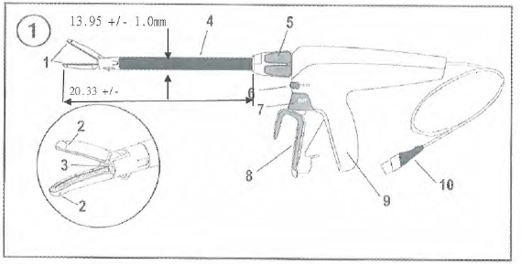

|  |  |
| --- | --- |
| Component | |
| 1. | Jaw |
| 2. | Cut line |
| 3. | Knife (not visible) |
| 4. | Shaft |
| 5. | 360° rotation knob |
| 6. | SEAL button |
| 7. | Cut button |
| 8. | Closing shaft |
| 9. | Grip |
| 10. | Attached power cord |

* 1. Body-contact materials:

|  |  |
| --- | --- |
| **Component** | **Material (being determined by manufacturer)** |
| 1 Jaw | Stainless steel/ polyether imide/polyphthalamide/silicon/isopropanol/aliphatic hydrocarbon/epoxy resin |
| 3 Knife (not visible) | Stainless steel/teflon |
| 4 Shaft | Stainless steel/polyethylene/acrylic ink |

1. **Performance indicators**
   1. Safety performance
      1. General requirement for safety of the sealer shall comply with the requirement of GB 9706.1-2007.
      2. Particular requirements for safety of the sealer shall comply with the requirement of GB 9706.4-2009.
      3. The Electromagnetic compatibility requirements of sealer shall comply with the requirements of YY 0505-2012 and Clause 36 of GB 9706.4-2009.
   2. Appearance

The color and luster of the sealer surface shall be uniform and sm ooth; the characters and icons are clear and firm, and no deformation, peeled coating, scratch or bubble shall occur.

* 1. Sterility
     1. Sealer sterilized by ethylene oxide shall be sterile.
     2. Ethylene oxide residues of sealer sterilized by ethylene oxide shall not exceed 4 mg/set.
  2. General performance of sealer
     1. The shaft outer diameter shall be 13.59 mm ± 1 mm and the shaft length from the jaw end to the rotation knob end shall be 20.33 cm +/- 1.00 cm.(specification)
     2. Clamping force of jaw: It shall not be less than 37 N.
     3. The hardness of the metal part of the sealer shall not be less than 120 HV0.2.
     4. The surface roughness of sealer shall not be greater than 0.8 μm.
     5. The cutting force of I-Blade shall not be greater than 47.06 N.
  3. Working performance of sealer

When the ENSEAL G2 Articulating Tissue Sealers and Ultrasonic Surgical & Electrosurgical Generator are connected, the EnSeal mode shall be started

* + 1. Ultrasonic Surgical & Electrosurgical Generator and the Sealer shall operate normally.
    2. The resistance value of sealer shall not exceed 8 Ω.

1. **Test methods**
   1. Safety performance:
      1. Conduct the test on the general requirements for safety of the sealer according to the methods specified in GB 9706.1-2007, and the result shall comply with the requirements of 2.1.1.
      2. Conduct the test on the particular requirements for safety of the sealer according to the methods specified in GB 9706.4-2009, and the result shall comply with the requirements of 2.1.2.
      3. Conduct the test on the particular requirements for safety of the sealer according to the methods specified in YY 0505-2012 and Clause 36 of GB 9706.4-2009, and the result shall comply with the requirements of 2.1.3.
   2. Visual inspection

Make the appearance inspection through visual observation and hand feeling; the result shall comply with the requirements of 2.2.

* 1. Sterility test
     1. Conduct the test according to the methods specified in the Chinese Pharmacopeia (Edition 2015 Volume II); the result shall comply with the requirements of 2.3.1.
     2. EO residues: Conduct the test according to the methods specified in GB 16886.7-2015; the result shall comply with the requirements of 2.3.2.
  2. General performance of sealer:
     1. Use a general measuring tool to make measurement; the result shall comply with the requirements of 2.4.1.
     2. The clamping force of the jaw is to clamp a coil (two loops) of Class II 1# suture complying with YY 1116-2010 at 1/2 site of the head end of clamp; after the weight of 37 N is lifted at the other end of the clamp, lift the weight along the direction perpendicular to the jaw in the closed state of the clamp jaw (pressing the closing shaft) and maintain the clamping state for 3 s; then the jaw shall not be damaged or deformed.
     3. Hardness test: Conduct the test according to the methods specified in GB 4340.1-2009; the result shall comply with the requirements of 2.4.3.
     4. Roughness test: Conduct the test according to the surface roughness comparison specimen methods; the result shall comply with the requirements of 2.4.4.
     5. Use Harmonic TL2605 torque to stimulate the fixture, fix the sealer sample on TL2456 handle fixture. Fix the test skin (5.08 cm * 5.08 cm, thickness: 0.14-0.17 mm, material: LDPE) on skin testing fixture TL2157 and place it into the jaw. One side of the test skin is aligned with proximal electrode edge of the lower jaw and contacted with the electrode surface of panel, making it a parallel surface. Control and stimulate the sealer with Labview software and collect the data of cutting force. Stimulate the fixed device TL2605 with Harmonic torque and measure the torque of sealer on the shaft with AC Servo motor and Lebow Model 7541. Divide the twisting force with arm of 5.72 cm and the data of twisting force will automatically convert to cutting force; the result shall comply with the requirements of 2.4.5.

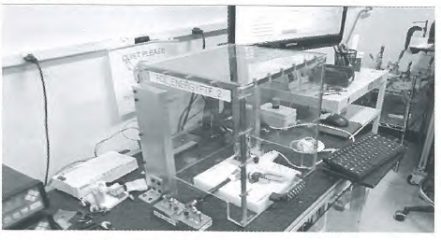

* 1. Working performance of sealer:
     1. After connecting the device to the generator and starting the Enseal mode, the system starts the self-test function, the screen shows normally ("Ready"), and the error is not reported; the result shall comply with the requirements of 2.5.1.
     2. Use a multimeter to measure the resistance; the result shall comply with the requirements of 2.5.2.

**Annex A**

1. **Product classification and safety characteristics**
2. Classification according to the type of protection against electric shock: Not applicable
3. Classification according to the degree of protection against electric shock: Type CF applied part
4. Classification according to the degree of protection against liquid ingress: Not applicable
5. Classification according to the safety degree of product used in the flammable anesthesia gas mixed with air, oxygen or nitrous oxide: Not applicable
6. Classification according to the operation mode: Not applicable
7. Rated voltage of accessory: 141.4 Vp; Rated frequency of equipment: Not applicable;
8. Input power of equipment: Not applicable
9. Whether the equipment has defibrillation-proof applied part: Not applicable
10. Whether the equipment has a signal input or output part: No
11. Permanently or non-permanently installed equipment: Non-permanently installed equipment
12. Electrical insulation diagram

**Insulation diagram**

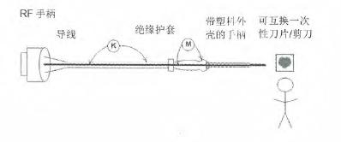

RF handle

Lead

Insulation sleeve

Handle with plastic coating

Interchangeable disposable blade/scissor

| Region | Insulation type: Operation insulation/basic insulation/assistant insulation/double insulation/reinforced insulation | Reference voltage (~V) | Test voltage (~V) | Essential creepage distance (mm) | Essential clearance (mm) | Insulation route |
| --- | --- | --- | --- | --- | --- | --- |
| K | DI/BI | 240/240 | 4000 | 8.0 | 5. 0 | B-e |
| M | SI/BI | 425/240 | 2850 | 4. 0 | 4. 0 | B-c |